# **Chapter 4: DESIGN**

## 4.0 System design

In this chapter we shall discuss the system design and architecture, we shall discuss in details using different system design modeling techniques to represent the architecture of the system.

## 4.1 Flow chart of the propose Web App.

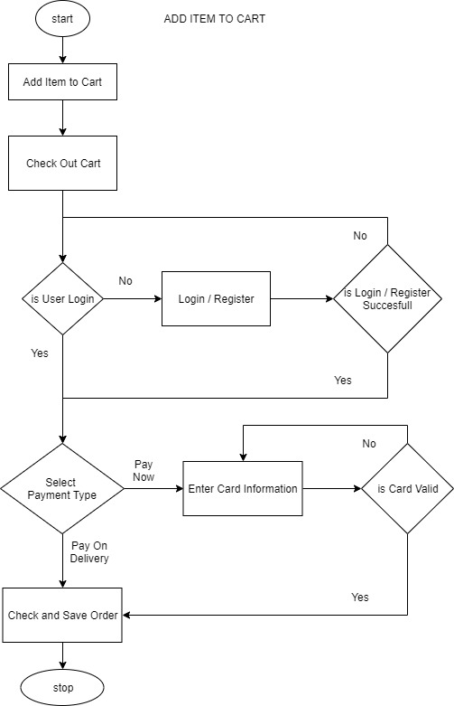

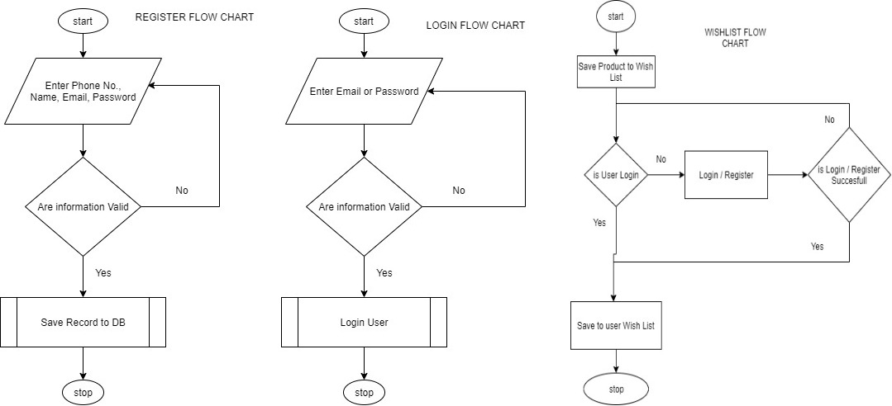

Figure 4.1: Flowchart of the Web App.

## 4.2 Use Case Diagram

The Use case diagram is illustrated in Figure 3.2 below it displays the diagrammatic representation of the user with the system. It enables the user to view the various activities that can be performed. The different users’ that have access to the Pharmacy E-Commerce web app can perform any of the listed operations.

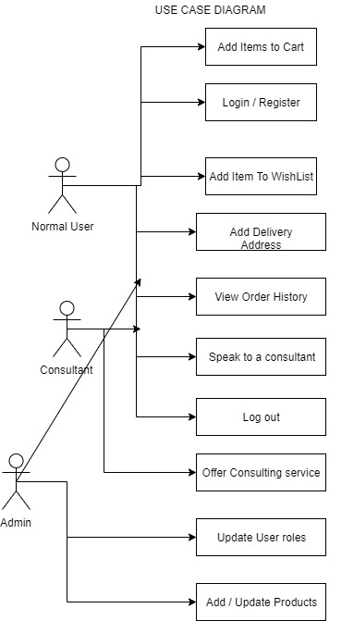

**Figure 4.2: Use case Diagram**

## 4.3 Block Diagram

The block diagram in Figure 3.3 below illustrates the design of the system. The user is provided access to the pharmacy e-commerce web app.

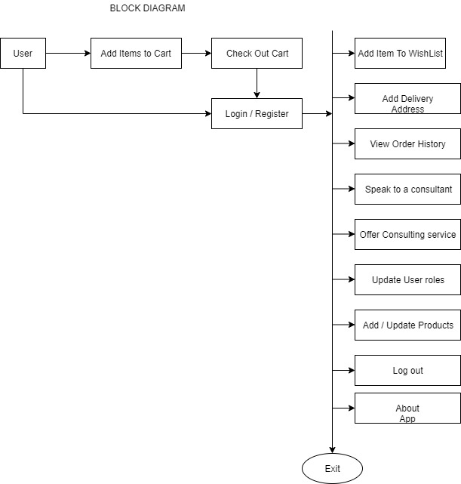

**Figure 4.3: System Block Diagram**

## 4.4 Sequence Diagram

The sequence diagram shows the interaction between objects in a sequential order that those interactions occur. The Sequence diagrams also demonstrate the behavior of objects in a use case by describing the objects and the messages they pass. The sequence diagram depicts interaction between objects in orders in which these interactions take place.

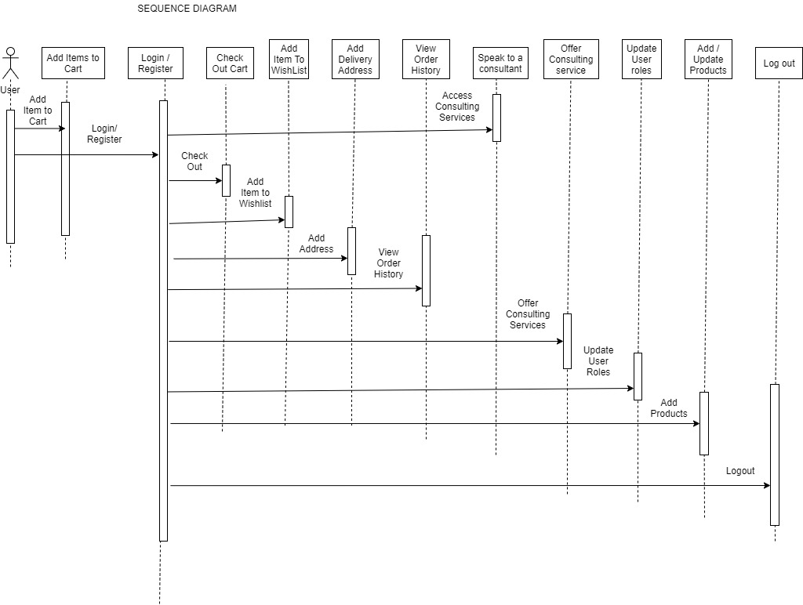

**Figure 4.4: The Sequence Diagram**

## 4.5 Architectural Context Diagram (ACD)

The ACD is used to model the manner in which software interacts with entities external to its boundaries. It shows the external entities that interact with the system, the systems that interact with the system, and systems that use and are used by the target system

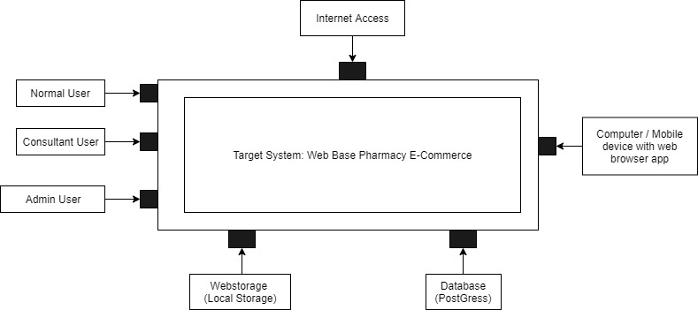

**Figure 4.5: Architectural Context Diagram (ACD) of the system**

## 4.6 System Architecture

A system architecture is the conceptual model that defines the structure, behavior, and more views of a system, An Architecture description is a formal description and representation of a system, organized in a way that supports reasoning about the structures and behaviors of the system by utilizing system architecture diagram to show the relationship between the different components. usually, they are created for systems which include hardware and software and these are represented in a diagram to show the interaction between them.

Below is the SAD of the proposed Pharmacy E-Commerce web App.

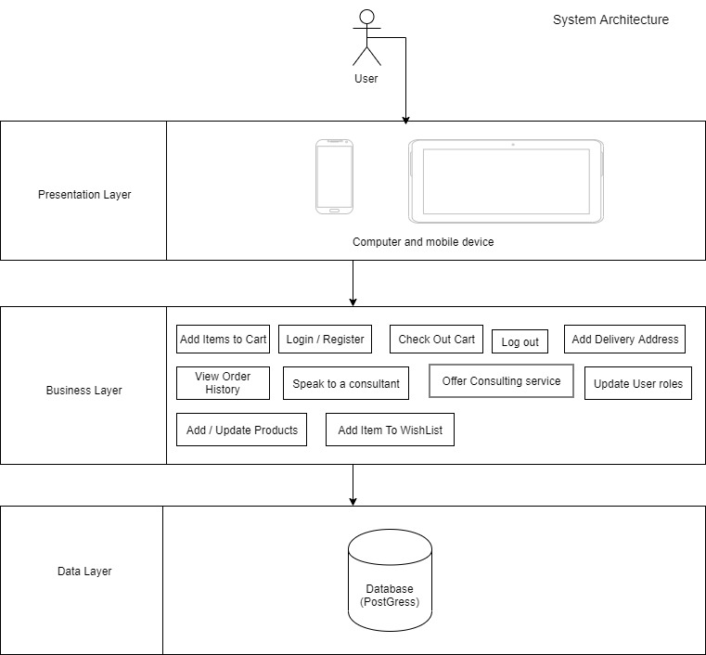

**Figure 4.6: System Architecture Diagram (SAD) of the system**

## 4.7 Entity Relationship Diagram

We have critically analyzed the nature of data required to build this system and we have structure the database to fit into our Architecture with so much emphasis on data normalization, integrity, retrieval and processing.

We have four entities(tables) in our database which are fully related to each other using database relationship.

We have use E-R Diagram to illustrate the relationship among the entities (table) in our database.

An entity-relationship diagram (ERD) is a data modeling technique that graphically illustrates an information system's entities and the relationships between those entities. An ERD is a conceptual and representational model of data used to represent the entity framework infrastructure.

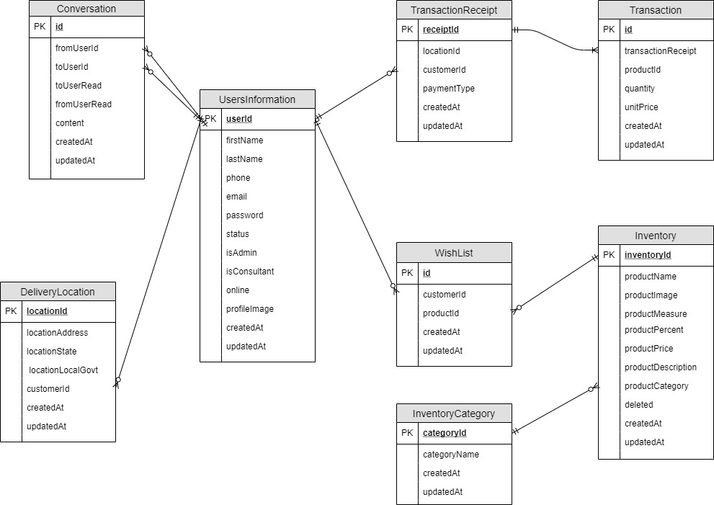

**Figure 4.7: Entity Relationship Diagram (ERD) of the system**

## 4.8 Wireframe Design

Wireframe is a blank template that allows creation of an app basic content layout, including interfaces and navigation, and how they work together.

Below is the wireframe design of the proposed system.

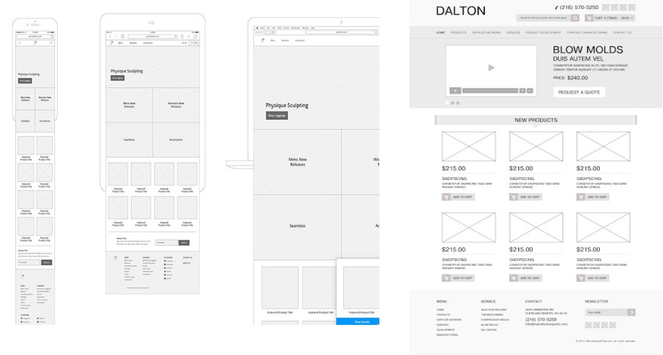

**Figure 4.8: Wireframe Diagram (ERD) of the system**